**Capstone Project: Create a Testing Framework for Sporty Shoes Website**

**Sporty Shoes API endpoints using Rest-Assured**

1. Setup or Configure REST Assured

**Development Environment:**

* Java 1.8
* Eclipse
* TestNG
* Maven

This guide has three subsections, namely:

3.1.1 Creating a Maven project in Eclipse

3.1.2 Updating the pom.xml file with the latest stable REST Assured dependencies

3.1.3 Pushing the code to GitHub repositories

**Step .1:** Creating a Maven project in Eclipse

REST Assured is an API designed for automating REST services or REST APIs.

* Open Eclipse.
* Click on File---> click on New--->Project.
* Select the Maven project and click on Next.

* Enter the Group id, Artifact id, and click on Finish.

* Right click on Project---> src/test/java---> Package.
* Enter the package name and click on Finish.

* Right click on Package---> New---> Class.
* Enter the class name and click on Finish.

**Step 3.1.2:** Updating the pom.xml file with the latest stable REST Assured dependencies

* Open the pom.xml file.

* Go to a browser and search for Maven repository.

* Add the dependencies to the pom.xml file.
* Click on Save.

**Step .2:** Adding Test Scripts

* Create a new class in your package and write the tests

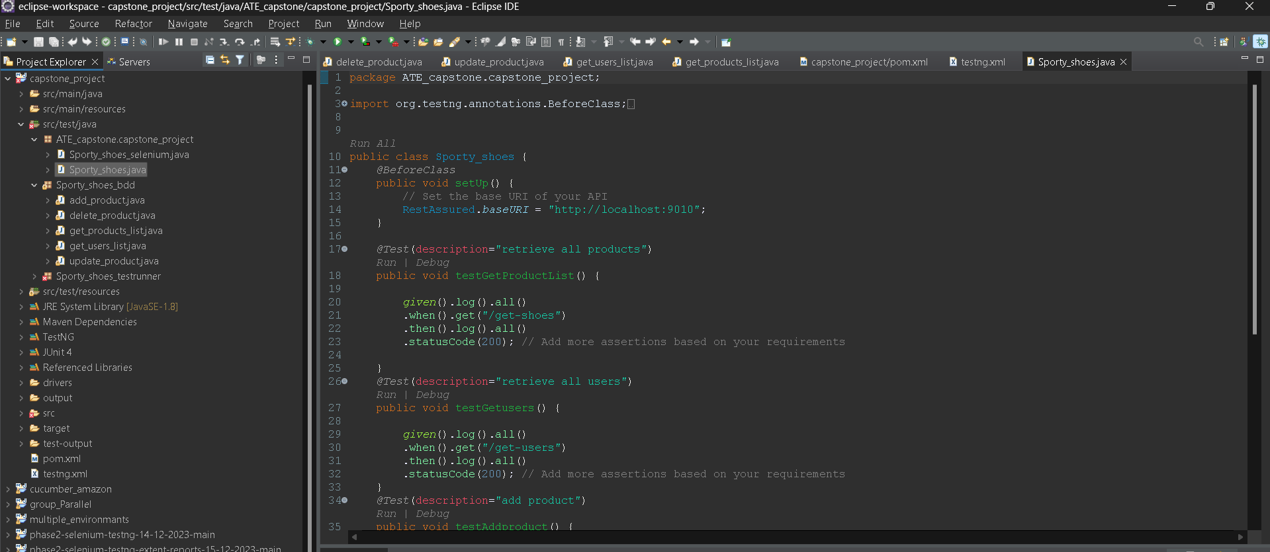

**Step .3:** Running Test Scripts.

* To run the tests right click on the file and select run as> testing test

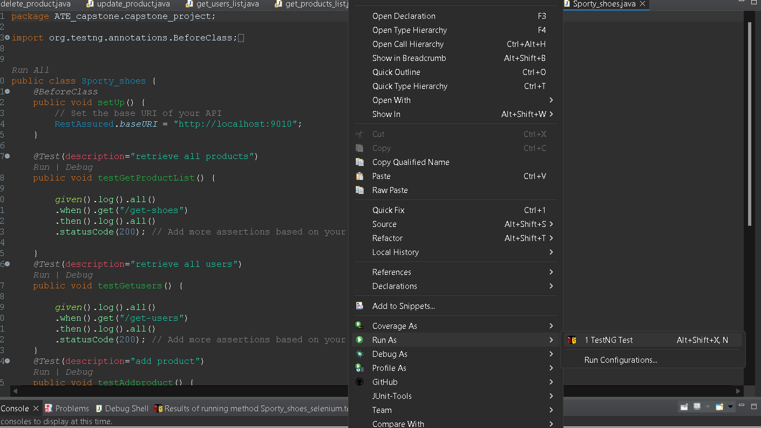

Push code to git repository

* Using git add .
* Git commit -m ”message”
* Git push -u <name> <link>